VISVESVARAYA TECHNOLOGICAL UNIVERITY
BELGAUM-590014



A DBMS Mini-Project Report
on
“Curfew e-pass Management system”
A Mini-project report submitted in partial fulfillment of the requirements for the
award of the degree of Bachelor of Engineering in Computer Science and Engineering of Visvesvaraya Technological University, Belgaum.

Submitted by:
NIHARIKA K(1DT19CS094)
AND
MADHU SUDHAN S(1DT19CS074)

Under the Guidance of:
Prof. K. Deepa Shree
(Asst. Prof. Dept of CSE)


Department of Computer Science and Engineering
DAYANADA SAGAR ACADEMY OF TECHNOLOGY AND
MANAGEMENT
Kanakapura Road,Udayapura, Bangalore-560 082
2021-2022

DAYANADA SAGAR ACADEMY OF TECHNOLOGY AND
MANAGEMENT,
Kanakapura Road,Udayapura, Bangalore -560 082

DEPARTMENT OF COMPUTER SCIENCE & ENGINEERING

CERTIFICATE

This is to certify that the Mini-Project on Database Management System (DBMS) entitled “Curfew e-pass Management system” has been successfully carried out by NIHARIKA K(1DT19CS094) and MADHU SUDHAN S(1DT19CS074) a bonafide students of Dayananda sagar academy of technology and management in partial fulfillment of the requirements for the award of degree in Bachelor of Engineering in Computer Science and Engineering of Visvesvaraya Technological University, Belgaum during academic year 2021-2022. It is certified that all corrections/suggestions indicated for Internal Assessment have been incorporated in the report deposited in the departmental library. The mini project report has been approved as it satisfies the academic requirements in respect of project work for the said degree.

Mini Project coordinator: Dr. M Ravishankar
Dr. Prashanth C M Principal, DSATM
Professor, Dept, of CSE

GUIDES:
Prof. K. Deepa Shree Dr. C. NANDINI
(Asst. prof. Dept od CSE) Vice Principal & HOD, Dept. of CSE

Examiners: Signature with Date
1:
2:

ACKNOWLEDGEMENT

It gives us immense pleasure to present before you our project titled “CURFEW E-
PASS MANAGEMENT SYSTEM”. The joy and satisfaction that accompany the
successful completion of any task would be incomplete without the mention of those v
who made it possible. We are glad to express our gratitude towards our prestigious
institution DAYANANDA SAGAR ACADEMY OF TECHNOLOGY AND MANAGEMENT
for providing us with utmost knowledge, encouragement and the maximum facilities
in undertaking this project.

We wish to express a sincere thanks to our respected principal Dr. M Ravishankar
for all their support.

We express our deepest gratitude and special thanks to Dr. C.Nandini, Vice Principal & H.O.D, Dept. Of Computer Science Engineering, for all her guidance and encouragement.

We sincerely acknowledge the guidance and constant encouragement of my mini-
project coordinator,
Dr. Prashanth CM, Professor , Dept of CSE and our mini-project guide
Prof. K. Deepashree, Asst, Professor, Dept of CSE

NIHARIKA K(1DT19CS094)
AND
MADHUSUDHAN S(1DT19CS074)

ABSTRACT

Curfew Pass Management system is a DBMS based project that will manage the records of pass which issue by administrative. Curfew Pass Management System is an automatic system that delivers data processing at a very high speed in a systematic manner.

In CPMS we use PHP and MySQL database. This is the project which keeps records of the pass which is issue by administrative. CPMS has one module i.e. admin.

Dashboard: In this sections, admin can briefly view the total number of category and how many pass will be generated in one day, yesterdays and last seven’s

days Category: In this section, admin can manage category (add/update).

Add Pass: In this section, admin adds pass.

Manage Pass: In this section, admin can update pass and take print of that pass.
Reports: In this section admin can generate pass reports between two dates.
Search: In this section, admin can search a particular pass bypass number.

Admin can also update his profile, change the password, and recover the password.

CONTENTS

SL.NO TITLE PAGE NO

1.  2. | DECLARATION  ACKNOWLEDGEMENT
3. | ABSTRACT | lV
4. | TABLE OF CONTENTS | V
Ch. 1 | INTRODUCTION | 01
 | 1.1 Project Overview | 02
Ch. 2 | SYSTEM SPECIFICATION | 03
 | 2.1 Hardware Requirements | 03
 | 2.2 Software Requirements | 03
Ch. 3 | IMPLEMENTATION | 04
 | 3.1 User Registration Module | 04
 | 3.2 User Category | 05
 | 3.3 Admin Operations Module | 06
 | 3.4 User Pass Registration | 07
 | 3.5 Between Dates Reports | 08
 | 3.6 Data connectivity  3.7 Source Code | 09  10
Ch. 4 | DESIGN DOCUMENT | 13
 | 4.1 levels of DFD | 15
 | 4.2 UML diagram | 17
 | 4.3 Use Case diagram | 19
 | 4.4 ER diagram | 21
Ch.5 | DATABASE DESIGN | 22
 | 5.1 Class diagram  5.2 Relational Schema | 23

Ch. 6 | SYSTEM TESTING | 24
 | 6.1 Unit testing | 25
 | 6.2 Integration testing | 25
 | 6.3 Performance testing | 25
Ch. 7 | OUTPUT SCREEN OF PROJECT | 26
 | CONCLUSION | 35
 | REFERENCES | 36

INTRODUCTION

Computers have become a way of life for today’s high society. Many aspects of modern life that we have come to accept as common place would not be possible if there were no computers. Today computers are used extensively in many areas of business, industry, science, education etc.
The major advantage of computer is its speed that makes it able to give some useful information very quickly. This speed also opens new approaches to problem solving and data processing. Another feature is its accuracy. Though the computers do only what is instructed at every instant, these instructions are taken into account and accurate information’s are produced.

Computer can hold data and instruction in an electronic representation in internal memory and this data can be retrieved at any time
The project entitled “Curfew E-Pass Management System” is a software package, which can be used in curfew for managing the pass of people’ computer efficiently.
This system is developed in PHP language with My SQL as backend. The system is a menu driven one. User-friendly menus will help the administrator to work on it without any operational difficulty.

Curfew Pass Management system is a DBMS based project that will manage the records of pass which is issue by administrative and also help to provide online curfew e-pass to people who need to travel compulsory. Curfew Pass Management System is an automatic system which delivers data processing in very high speed in systematic manner.

1.1 PROJECT OVERVIEW

Curfew Pass Management system is a DBMS based project that will manage the records of pass which is issue by administrative and also help to provide online curfew e-pass to people who need to travel compulsory. Curfew Pass Management System is an automatic system which delivers data processing in very high speed in systematic manner.

In CPMS we use PHP and MySQL database. This is the project which keeps records of the pass which is issue by administrative. CPMS has one module i.e. admin.

Dashboard: In this sections, admin can briefly view the total number of category and how many pass will be generated in one day, yesterdays and last seven’s days Category: In this section, admin can manage category (add/update).
Add Pass: In this section, admin add pass.
Manage Pass: In this section, admin can update pass and take print of that pass .
Reports: In this section admin can generate pass reports between two dates.
Search: In this section, admin can search a particular pass by pass number.
Admin can also update his profile, change the password and recover the
password.

Brief Information about homepage
User can visit home page and search pass details by entering pass number. Note: In this project MD5 encryption method used.

SOFTWARE AND HARDWARE SPECIFICATIONS

HARDWARE REQUIREMENTS:

Processor : Intel P-IV based system

Processor Speed : 2.0. GHz

RAM : 1GB

Hard Disk : 40GB to 80GB

SOFTWARE REQUIREMENTS:

Database : MySQL

Server : Apache

Frontend : HTML

Scripting language : Java Script

IDE : Vs Code

Technology : PHP

CHAPTER 3

IMPLEMENTATION

3.1 User Registration Module

Process Name | : Admin Profile
Process Number | : 1.1
Input | :Full Name  : Username  : Email  : Mobile Number  : Password
Output | : Status Message
Error Condition | : Username Already Exists  : Passwords do not match  : All Fields are Required

Process Name | : User Login
Process Number | : 1.2
Input | : Username  : Password
Output | : Status Message
Error Condition | : Invalid Username or Password  : All Fields are Required

3.2 User Category

Process Name | : Add Category
Process Number | : 2.1
Input | : Category Name
Output | : Category has been added
Error Condition | : Enter valid name

Process Name | : Manage Category
Process Number | : 2.2
Output | : Available Category Details
Error Condition | : No Category

3.3 Admin Operations Module

Process Name | : Insert New Sub-admin
Process Number | : 3.1
Input | : ID  : Full Name  : Username(used for login)  : Email id  : Mobile Number  : Password
Output | : Status Message
Error Condition | : Username Already Exists  : All fields are Required

Process Name | :Update User Details
Process Number | : 3.2
Output | : Sub-admin details has been updated.
Error Condition | : Query error

3.4 User Pass Registration

Process Name | : Add Pass
Process Number | : 4.1
Input | : Full Name  : Contact Number  : Email  : Identity Type  : Identity Card No  : Category  : From Date  : To Date
Output | : Status Message
Error Condition | : Username Already Exists  : All Fields are Required

Search Pass

Process Name | : Search Pass
Process Number | : 4.2
Input | : Input ID
Output | : Output table
Error Condition | : Enter valid PassNumber

3.5 Between Dates Reports

Process Name | : Between Dates Reports
Process Number | : 5.1
Input | : Input From Date  : Input To Date
Output | : Output table
Error Condition | : All the fields are required

Created by Reports

Process Name | : Created by Reports
Process Number | : 5.2
Input | : Input From Date  : Input To Date
Output | : Output table
Error Condition | : All the fields are required

3.6 Database Connectivity

A database connection is a facility in computer science that allows client software to
talk to database server software, whether on the same machine or not. A connection
is required to send commands and receive answers, usually in the form of a result
set. Connections are a key concept in data-centric programming.

3.7 DB Connectivity

<?php
$con=mysqli_connect("localhost", "root", "", "crm");
if(mysqli_connect_errno()){
echo "Connection Fail".mysqli_connect_error();
}
?>

*Localhost:
Localhost is often used in Web scripting languages like PHP and ASP when defining what server the code should run from or where a database is located.

*mysqli_connect():
The connect() / mysqli_connect() function opens a new connection to the MySQL server.

*root:
The PHP document root is the folder where a PHP script is running. When installing a script, web developers often need to know the document root. Although many pages scripted with PHP run on an Apache server, some run under Microsoft IIS on Windows.

3.8 SOURCE CODE

Sample Code: Login.php

<?php
session_start();
include('includes/dbconnection.php');
?>
<!DOCTYPE html>
<html lang="en">
<head>
<title>Curfew e-Pass Management System - Home</title>
<link rel="stylesheet" href="vendors/bootstrap/bootstrap.min.css">
<link rel="stylesheet" href="vendors/themify-icons/themify-icons.css">
<link rel="stylesheet" href="vendors/owl-carousel/owl.theme.default.min.css">
<link rel="stylesheet" href="vendors/owl-carousel/owl.carousel.min.css">
<link rel="stylesheet" href="css/style.css">
</head>
<body>
<?php include_once('includes/header.php');?>
<section class="hero-banner text-center">
<div class="container">
<h1>Curfew e-Pass Management System</h1>
</div>
</section>
<section class="bg-gray domain-search">
<div class="container">
<div class="row no-gutters">
<div class="col-md-5 col-lg-2 text-center text-md-left mb-3 mb-md-0">
<h3>Search Your Pass!</h3>
</div>
<div class="col-md-7 col-lg-10 pl-2 pl-xl-5">
<form class="form-inline flex-nowrap form-domainSearch" method="post">
<div class="form-group">
<label for="staticDomainSearch" class="sr-only">Search</label>
<input id="searchdata" type="text" name="searchdata" required="true"

class="form-control" placeholder="Enter Your Pass ID">
</div>
<button type="submit" class="button rounded-0" name="search" id="submit">Search</button>
</form>
<?php
if(isset($_POST['search']))
{
$sdata=$_POST['searchdata'];
?>
<h4 align="center">Result against "<?php echo $sdata;?>" Pass Id </h4>
<table class="table table-striped table-bordered table-hover" id="dataTables-example" style="color:#000">
<?php
$sql="SELECT * from tblpass where PassNumber like '%$sdata%'";
$query = $dbh -> prepare($sql);
$query->execute();
$results=$query->fetchAll(PDO::FETCH_OBJ);
$cnt=1;
if($query->rowCount() > 0)
{
foreach($results as $row)
{ ?>
<tr align="center">
<td colspan="6" style="font-size:20px;color:blue">
Pass ID: <?php echo ($row->PassNumber);?></td></tr>
<tr>
<th scope>Full Name</th>
<td><?php echo ($row->FullName);?></td>
<th scope>Category</th>
<td><?php echo ($row->Category);?></td>
</tr>
<tr>
<th scope>Email</th>
<td><?php echo ($row->Email);?></td>
<th scope>Mobile Number</th>

<td><?php echo ($row->ContactNumber);?></td>
</tr>
<tr>
<th scope>Identity Type</th>
<td><?php echo ($row->IdentityType);?></td>
<th scope>Identity Card Number</th>
<td><?php echo ($row->IdentityCardno);?></td>
</tr>
<tr>
<th scope>From Date</th>
<td><?php echo ($row->FromDate);?></td>
<th scope>To Date</th>
<td><?php echo ($row->ToDate);?></td>
</tr>
<tr>
<th scope>Pass Created by</th>
<td><?php echo ($row->CreatedBy);?></td
<th scope>Pass Creation Date</th>
<td><?php echo ($row->PasscreationDate);?></td>
</tr>

<?php
$cnt=$cnt+1;
} } else { ?>
<tr>
<td colspan="8"> No record found against this search</td>
</tr>
<?php } }?>
</table>
</div>
</div>
</div>
</section>
<?php include_once('includes/footer.php');?>
<script src="vendors/jquery/jquery-3.2.1.min.js"></script>
<script src="vendors/bootstrap/bootstrap.bundle.min.js"></script>
<script src="vendors/owl-carousel/owl.carousel.min.js"></script>
<script src="js/jquery.ajaxchimp.min.js"></script>
<script src="js/mail-script.js"></script>
<script src="js/main.js"></script>
</body>
</html>

CHAPTER 4

DATA FLOW DIAGRAM

- The entire system is projected with a physical diagram which specifics the actual storage parameters that are physically necessary for any database to be stored on to the disk. The overall systems existential idea is derived from thisdiagram.

- The relation upon the system is structure through a conceptual ER-Diagram, which not only specifics the existential entities but also the standard relations through which the system exists and the cardinalities that are necessary for the system state to continue.

  - The content level DFD is provided to have an idea of the functional inputs and outputs that are achieved through the system. The system depicts the input and output standards at the high level of the systems existence.

A DFD does not show a sequence of steps. A DFD only shows what the different process in a system is and what data flows between them

External entities

Process: A transaction of information that resides within the bounds of the system to be module.
DATAFLOWS

RULES FOR DFD:
DATASTORE: A repository of data that is to be stored for use by one or more processes, may be as simple as buffer of queue or as a relational database.

    - Fix the scope of the system by means of context diagrams.
    - Organize the DFD so that the main sequence of the actions reads left to right and top to bottom.
    - Identify all inputs and outputs.
    - Identify and label each process internal to the system with rounded circles.
    - A process is required for all the data transformation and transfers. Therefore, never connect a data store to a data source or the destinations or another data store with just a data flow arrow.
      - Do not indicate hardware and ignore control information.
      - Make sure the names of the processes accurately convey everything the process is done.
      - There must not be unnamed process

          - Number each occurrence of repeated external entities.
          - Identify all data flows for each process step, except simple Record retrievals.
          - Label data flow on each arrow.
          - Use details flow on each arrow.
          - Use the details flow arrow to indicate data movements.
          - There can’t be unnamed data flow.
          - A data flow can’t connect two external entities.

LEVELS OF DFD:

The complexity of the business system means that it is a responsible to represent the operations of any system of single data flow diagram. At the top level, an Overview of the different systems in an organization is shown by the way of context analysis diagram. When exploded into DFD

They are represented by:
    - LEVEL-0 : SYSTEM INPUT/OUTPUT
    - LEVEL-1:SUBSYSTEM LEVEL DATAFLOW FUNCTIONAL
    - LEVEL-2: FILE LEVEL DETAIL DATA FLOW.
The input and output data shown should be consistent from one level to the next.

LEVEL-0: SYSTEM INPUT/OUTPUT LEVEL
A level-0 DFD describes the system-wide boundaries, dealing inputs to and outputs from the system and major processes. This diagram is similar to the combined user-level context diagram.

LEVEL-1: SUBSYSTEM LEVEL DATA FLOW
A level-1 DFD describes the next level of details within the system, detailing the data flows between subsystems, which makeup the whole.

LEVEL-2: FILE LEVEL DETAIL DATA FLOW
All the projects are feasible given unlimited resources and infinite time. It is both necessary and prudent to evaluate the feasibility of the project at the earliest possible time. Feasibility and the risk analysis are pertained in many ways. If project risk is great.

FIRST LEVEL DATA FLOW DIAGRAM

0.0

Curfew E-Pass Management System
Admin

1.2

Admin

2nd Level DFDs

1.1
User Details
DB
DB

1.1.1.1
Add
User Details
Computer
Info
Admin

  - Unified Modeling Language Diagrams(UML):

    - The unified modeling language allows the software engineer to express an analysis model using the modeling notation that is governed by a set of syntactic semantic and pragmatic rules.
    - A UML system is represented using five different views that describe the system from distinctly different perspective. Each view is defined by a set of diagram, which is as follows.

User Model View

- This view represents the system from the users perspective.

- The analysis representation describes a usage scenario from the end-users perspective.

Structural model view

  - In this model the data and functionality are arrived from inside the system.

  - This model view models the static structures.

Behavioral Model View

  - It represents the dynamic of behavioral as parts of the system, depicting the interactions of collection between various structural elements described in the user model and structural model view.

Implementation Model View

  - In this the structural and behavioral as parts of the system are represented as they are to be built.

Environmental Model View

In this the structural and behavioral aspects of the environment in which the system is to be implemented are represented.
UML is specifically constructed through two different domains they are

  - UML Analysis modeling, which focuses on the user model and structural model views of the system?
  - UML design modeling, which focuses on the behavioral modeling, implementation modeling and environmental model views.

Use Case Diagrams: User

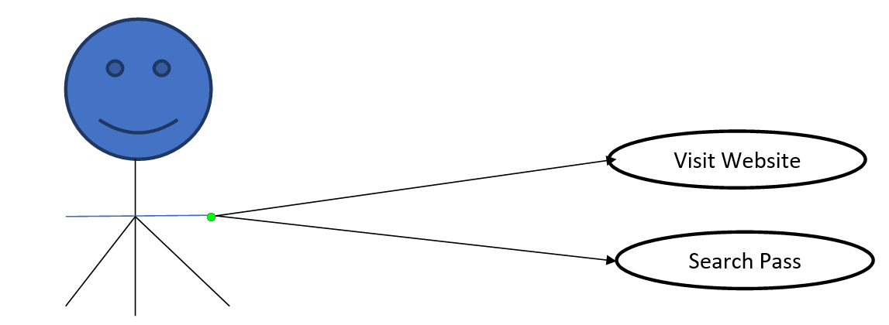

4.3.1 Use Case Diagrams: Admin

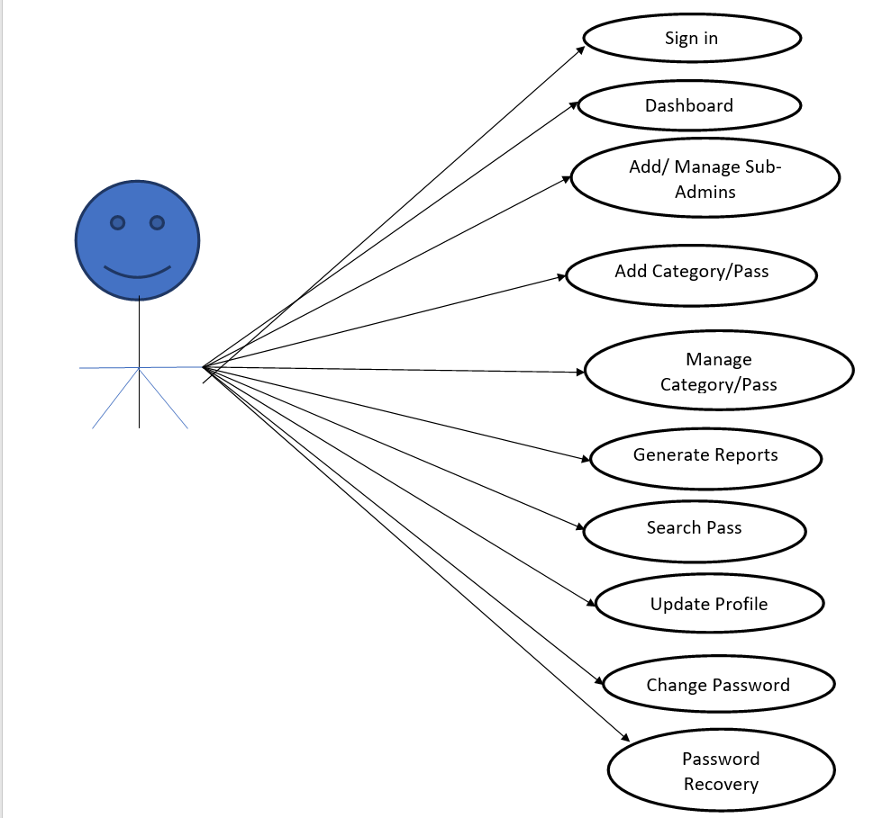

4.3.2 Use Case Diagrams: Sub-Admin

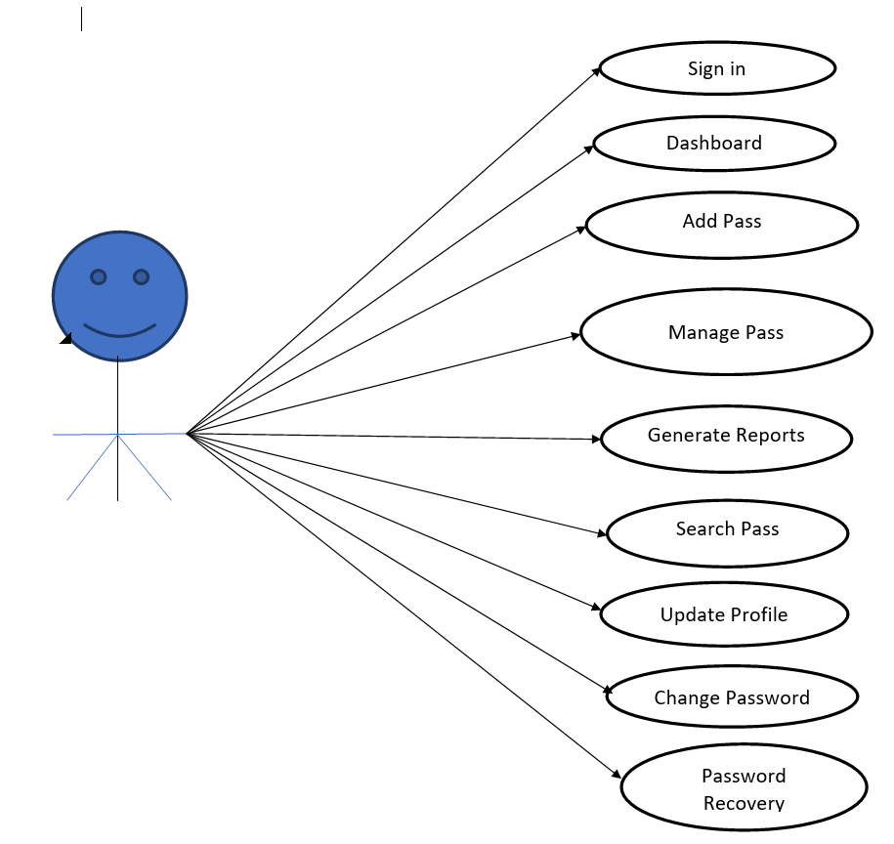

4.4 ENTITY-RELATIONSHIP Diagrams

E-R (Entity-Relationship) Diagram is used to represents the relationship between
entities in the table.

The symbols used in E-R diagrams are:

SYMBOL PURPOSE

Represents Entity sets.

Represent attributes.

Represent Relationship Sets.

Line represents flow

Structured analysis is a set of tools and techniques that the analyst. To develop a new kind of a system:
The traditional approach focuses on the cost benefit and feasibility analysis, Project management, and hardware and software selection a personal considerations.

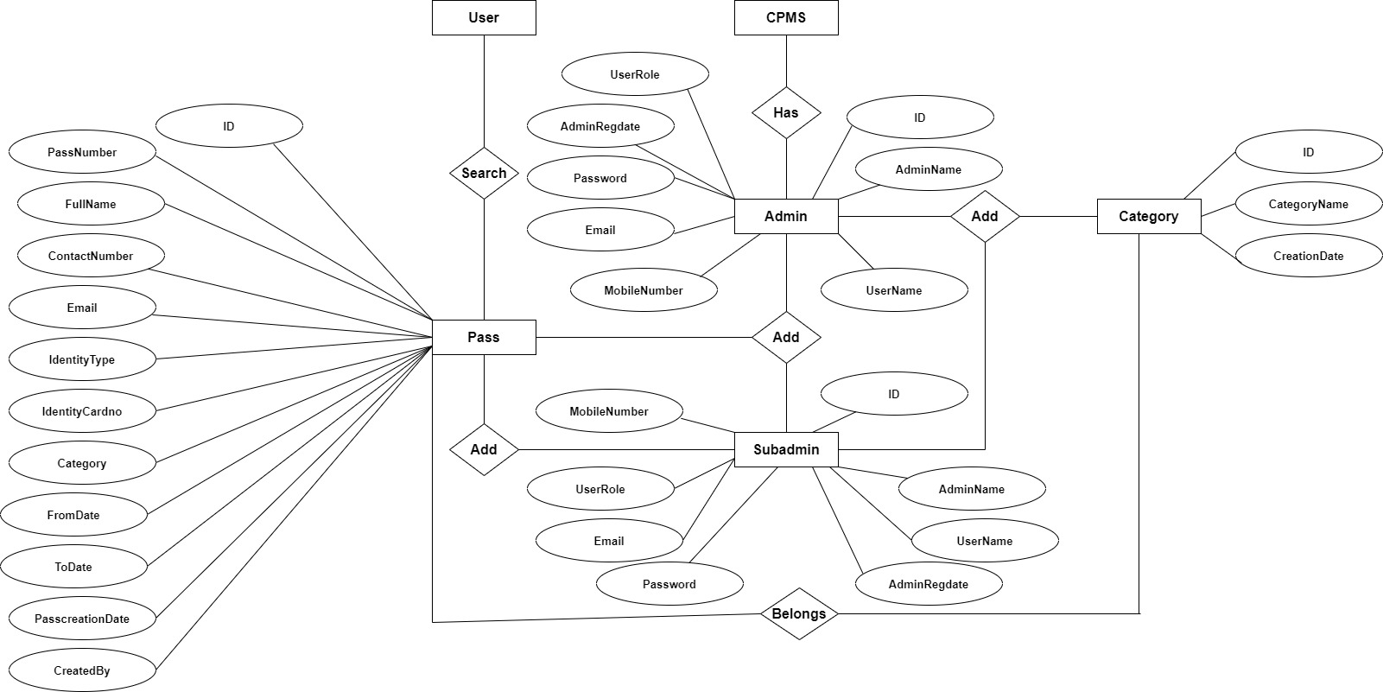

CHAPTER 5

DATABASE DESIGN

The data in the system has to be stored and retrieved from database. Designing the database is part of system design. Data elements and data structures to be stored have been identified at analysis stage. They are structured and put together to design the data storage and retrieval system.

A database is a collection of interrelated data stored with minimum redundancy to serve many users quickly and efficiently. The general objective is to make database access easy, quick, inexpensive and flexible for the user. Relationships are established between the data items and unnecessary data items are removed. Normalization is done to get an internal consistency of data and to have minimum redundancy and maximum stability. This ensures minimizing data storage required, minimizing chances of data inconsistencies and optimizing for updates. The MS Access database has been chosen for developing the relevant databases.

Curfew E-Pass Management System Project (CPMS) contains 3 MySQL tables :

tbladmin table Structure : This table store the login and personal details of admin.
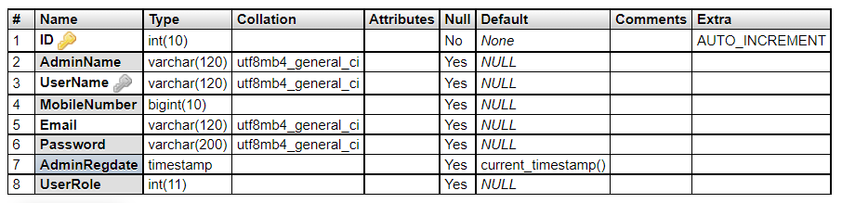

tblcategory table Structure : This table store the category of pass.
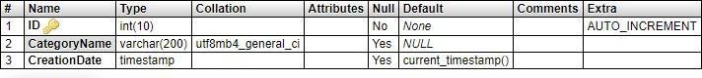

tblcategory table Structure : This table store the pass details of person.

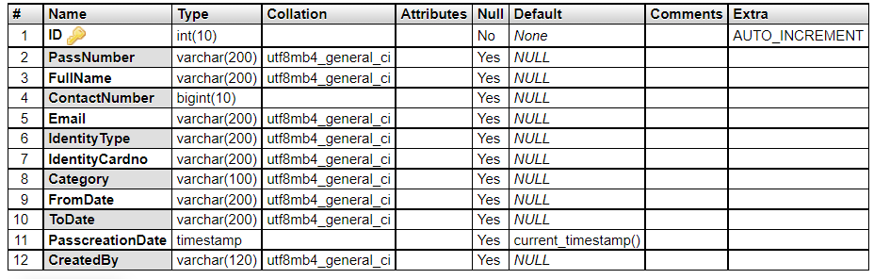

Class Diagram:

The class diagram shows a set of classes, interfaces, collaborations and their relationships.

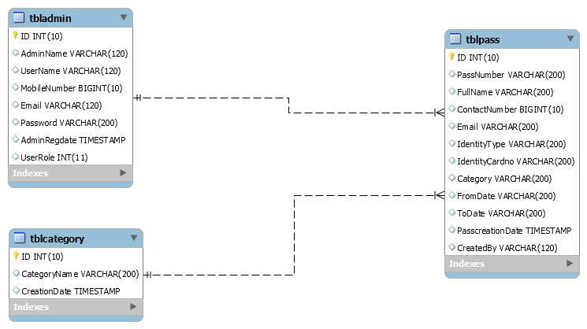

Relational Schema

Database: Curfew E-pass Management System

Admin

ID UserName AdminName MobileNumber Email Password AdminRegdate UserRole

Subadmin

ID UserName SubAdminName MobileNumber Email Password SubAdminRegdate UserRole

Category

ID CategoryName CreationDate

Pass
ID PassNumber FullName Email ContactNumber IdentityType IdentityCardno FromDate ToDate PasscreationDate CreatedBy

CHAPTER 6

SYSTEM TESTING

SOFTWARE TESTING TECHNIQUES:

Software testing is a critical element of software quality assurance and represents the ultimate review of specification, designing and coding.

TESTING OBJECTIVES:

    - Testing is process of executing a program with the intent of finding an error.

    - A good test case design is one that has a probability of finding an as yet undiscovered error.

    - A successful test is one that uncovers an as yet undiscovered error.

These above objectives imply a dramatic change in view port.

Testing cannot show the absence of defects, it can only show that software errors are present. There are three types of testing strategies

- Unit test
- Integration test
- Performance test

Unit Testing:
Unit testing focuses verification efforts on the smallest unit of software design module. The unit test is always white box oriented. The tests that occur as part of unit testing are testing the module interface, examining the local data structures, testing the boundary conditions, execution all the independent paths and testing error-handling paths.

Integration Testing:
Testing is a systematic technique or construction the program structure while at the same time conducting tests to uncover errors associated with interfacing. Scope of testing summarizes the specific functional, performance, and internal design characteristics that are to be tested. It employs top-down testing and bottom-up testing methods for thiscase.

Performance Testing:

Timing for both read and update transactions should be gathered to determine whether system functions are being performed in an acceptable timeframe.

CHAPTER 7

Output Screen of Project

Home Page

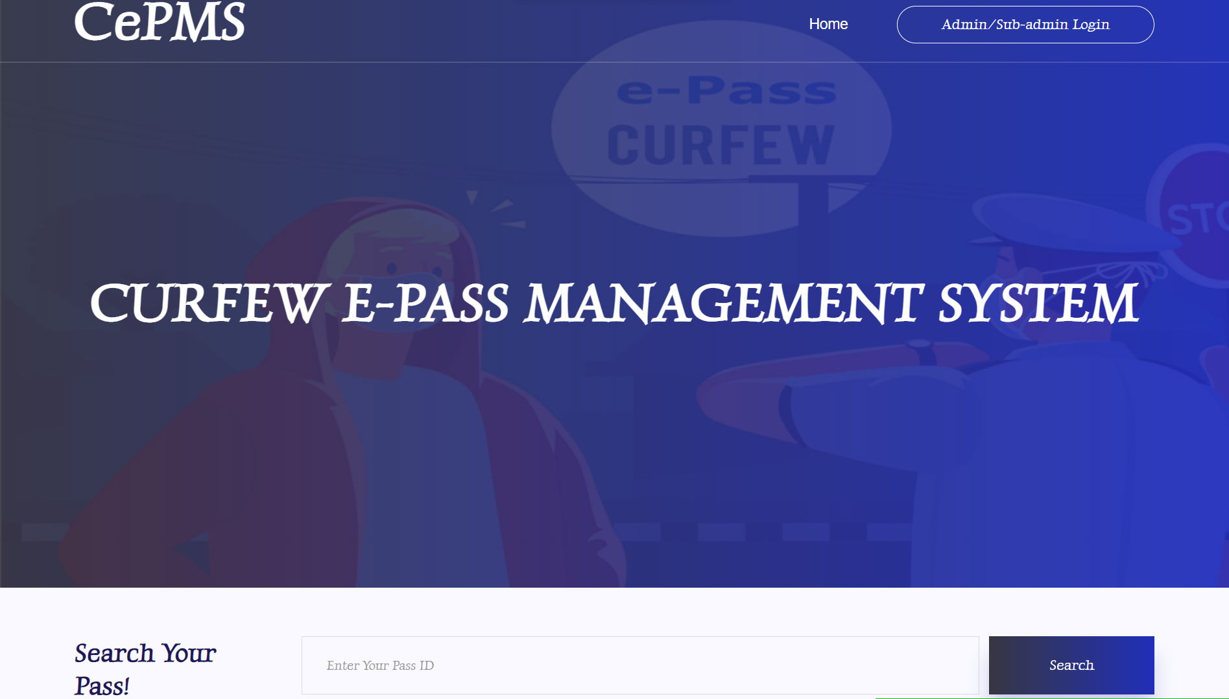

Screenshot 7.1 home page

Admin Login
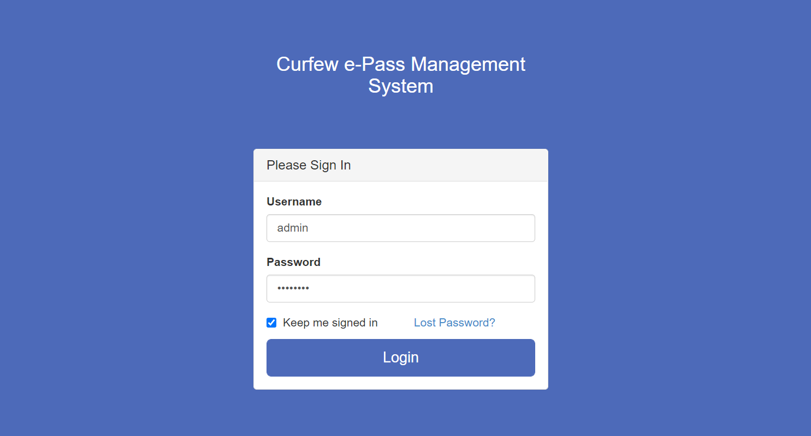
Screenshot 7.2 Admin login

Dashboard
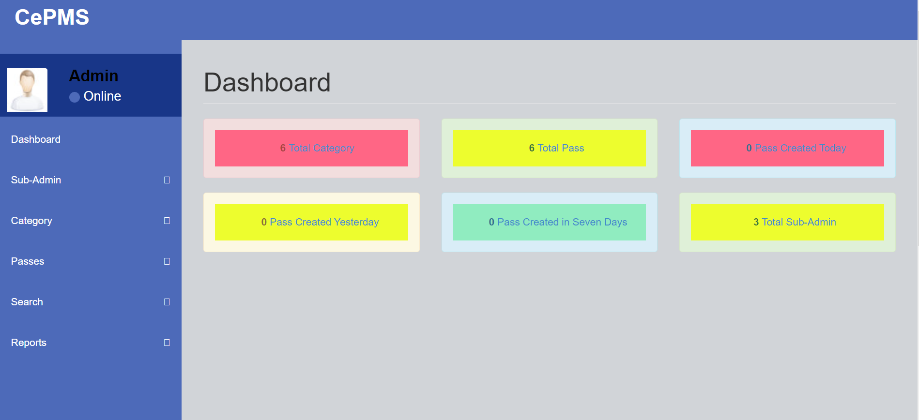

` Screenshot 7.3 Dashboard

Profile
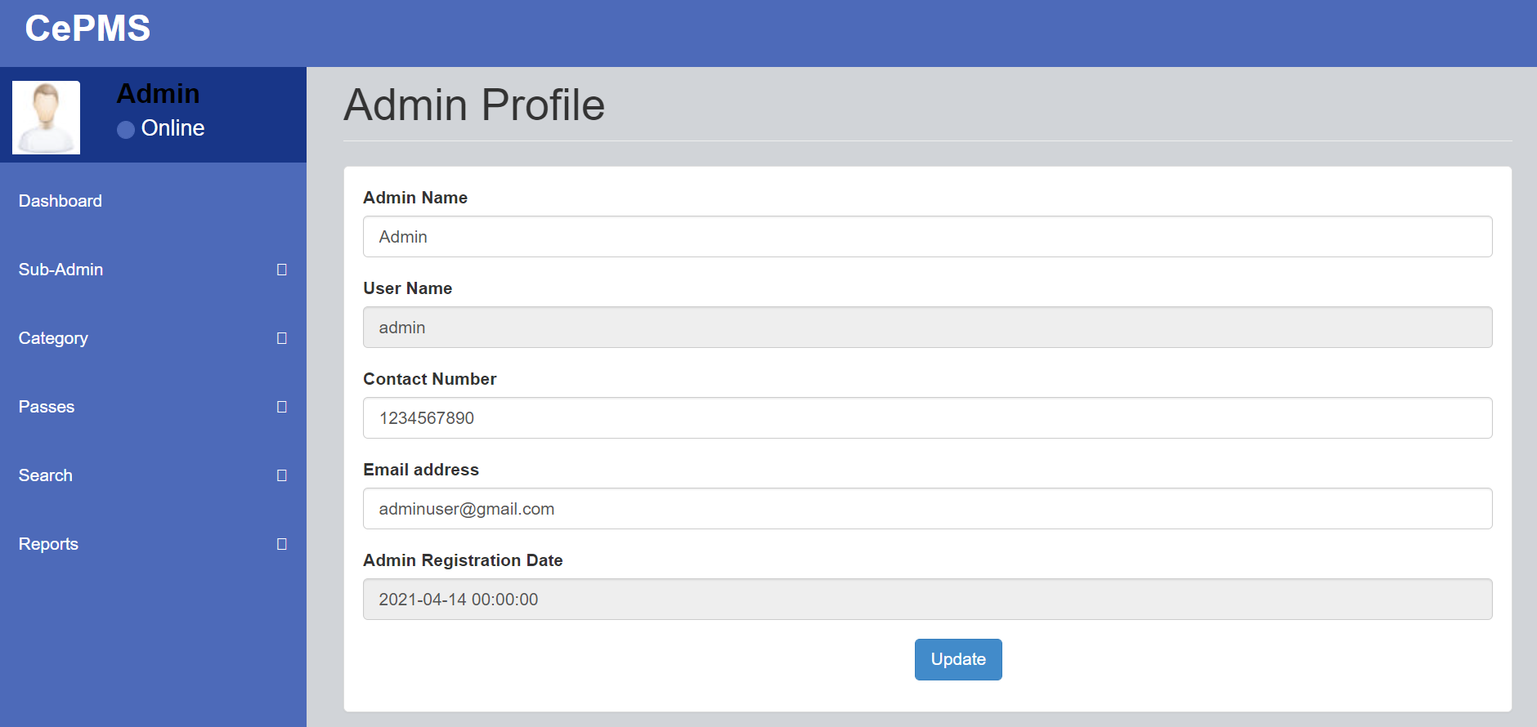
Screenshot 7.4 Admin Profile

Change Password

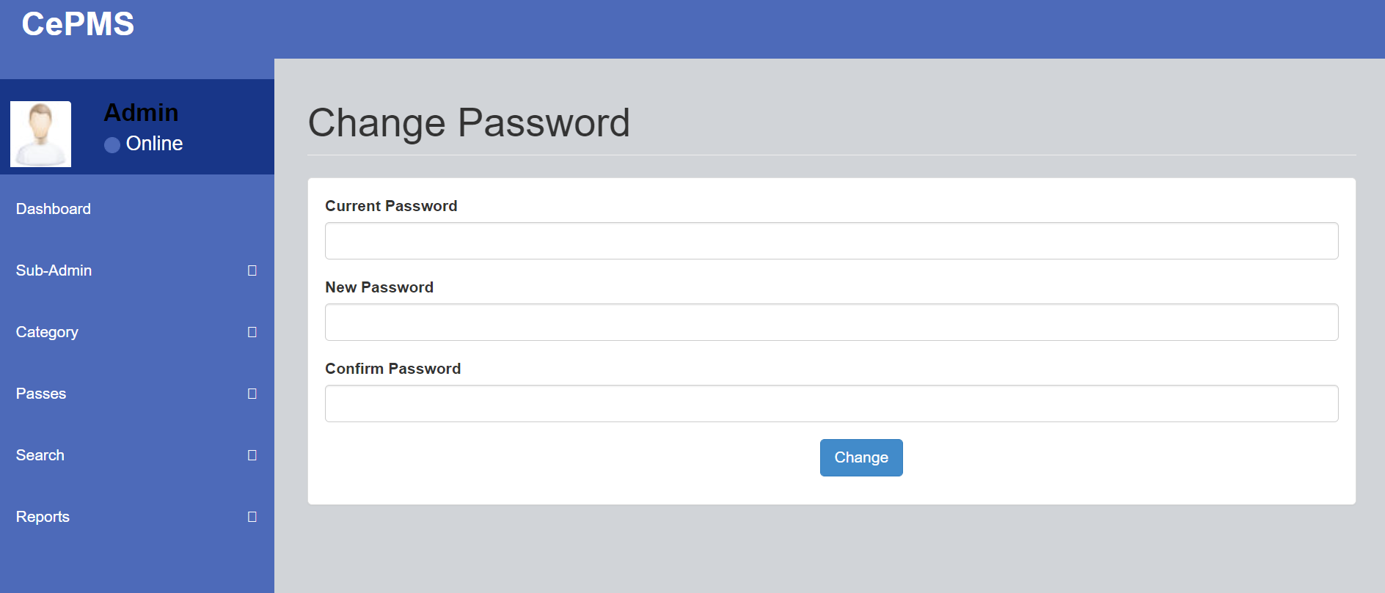

Screenshot 7.5 Change password

Add Category

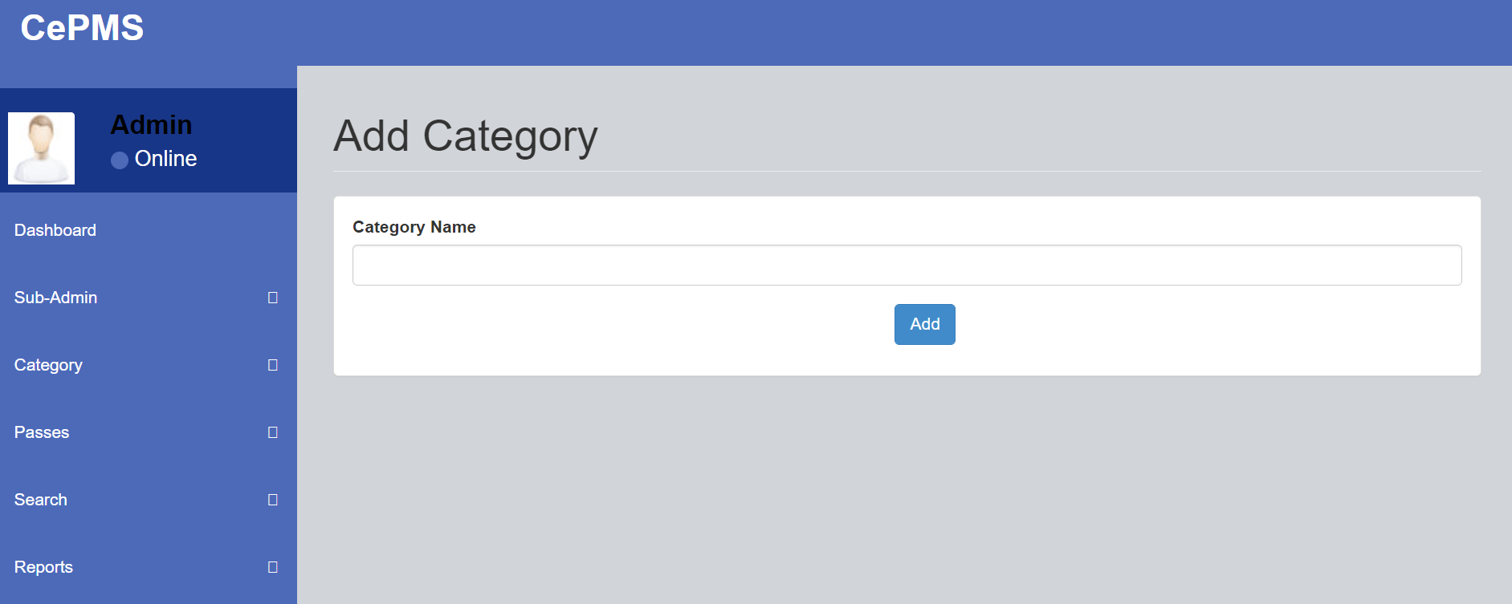

Screenshot 7.6 Add Category

Manage Category
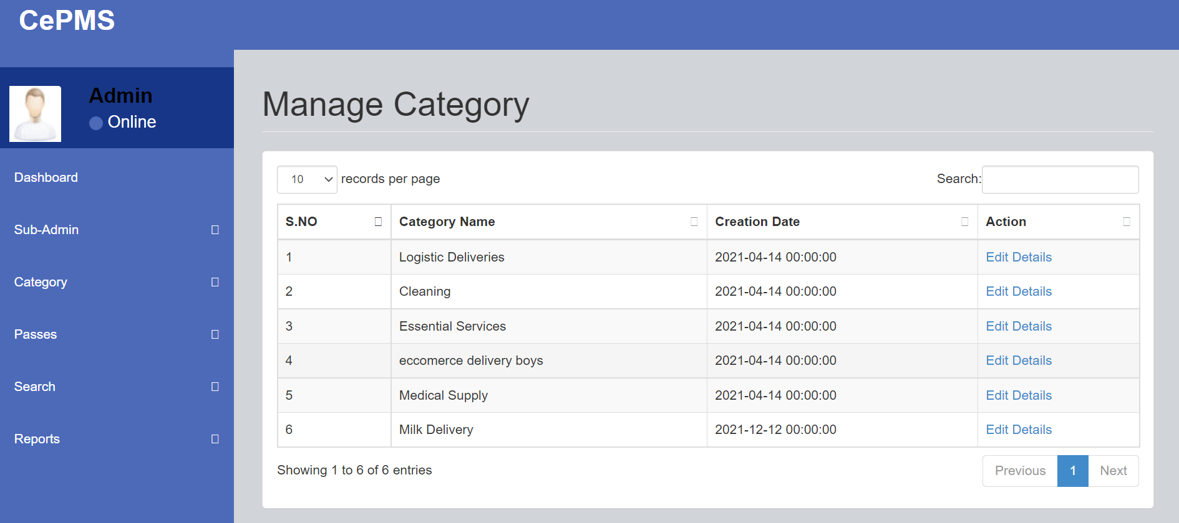
Screenshot 7.7 Manage Category

Update Category
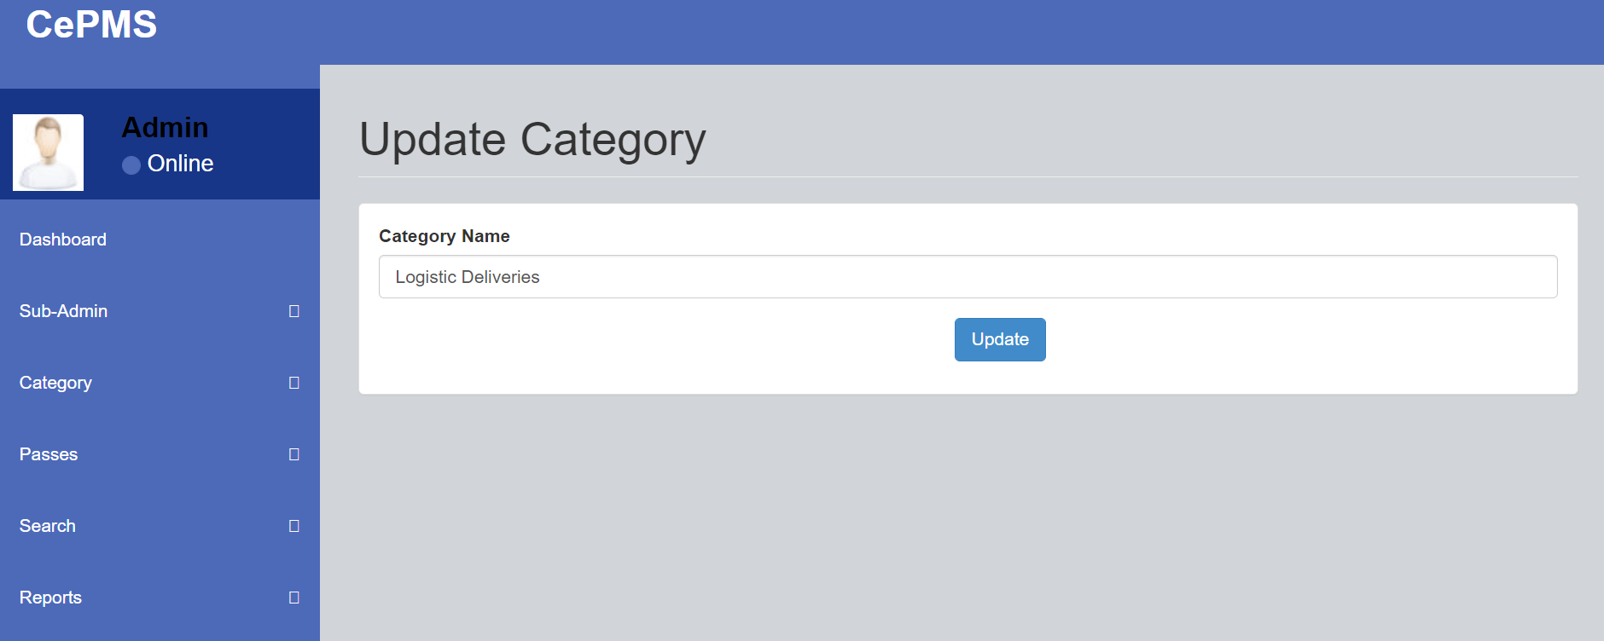
Screenshot 7.8 Update Category

Add Pass
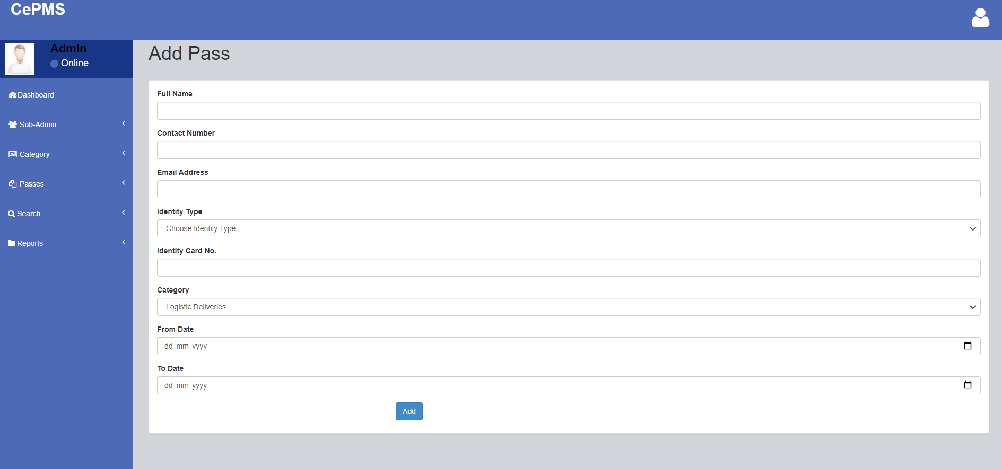

Screenshot 7.9 Add Pass

Manage Pass
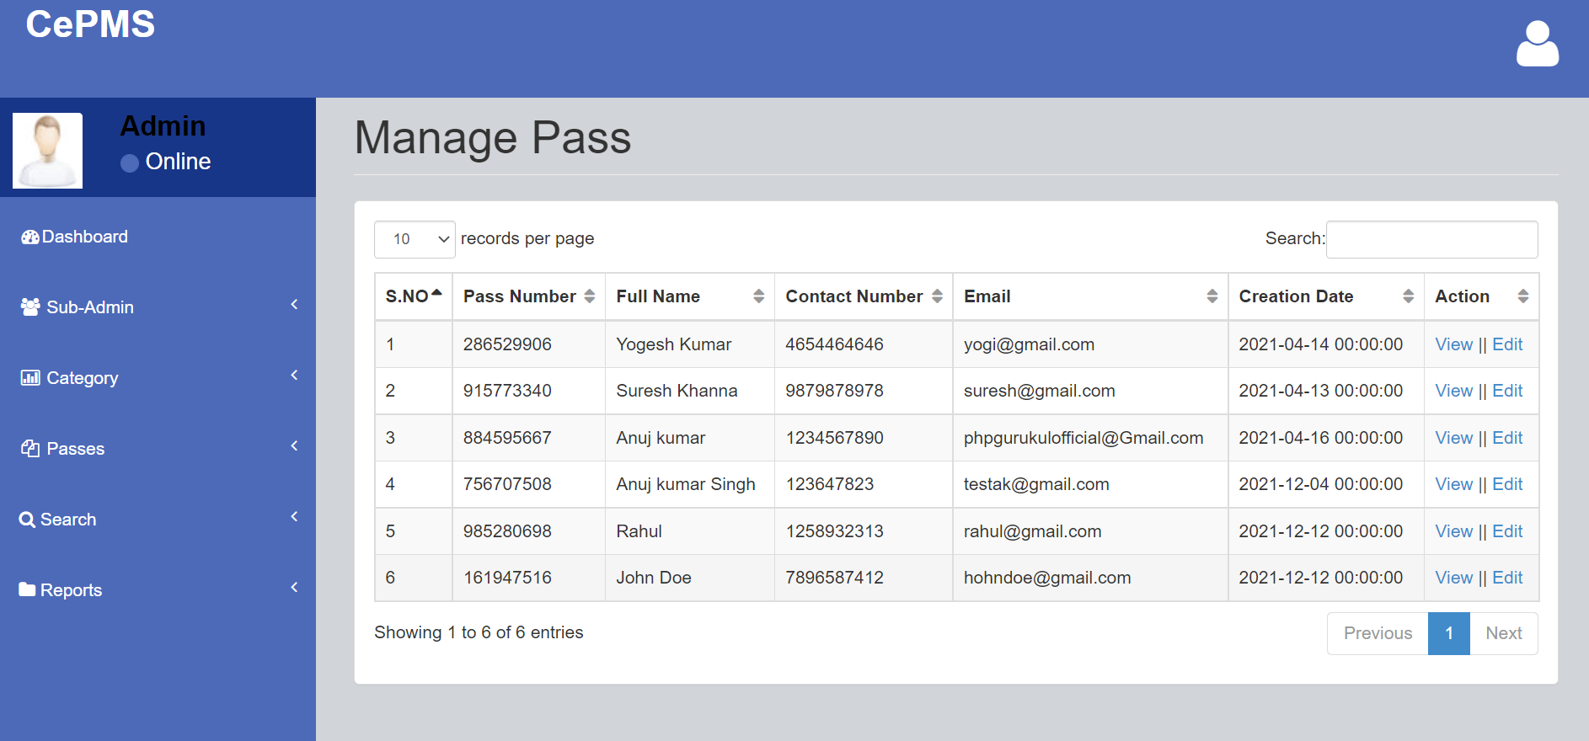

Screenshot 7.10 Manage Pass

View Pass
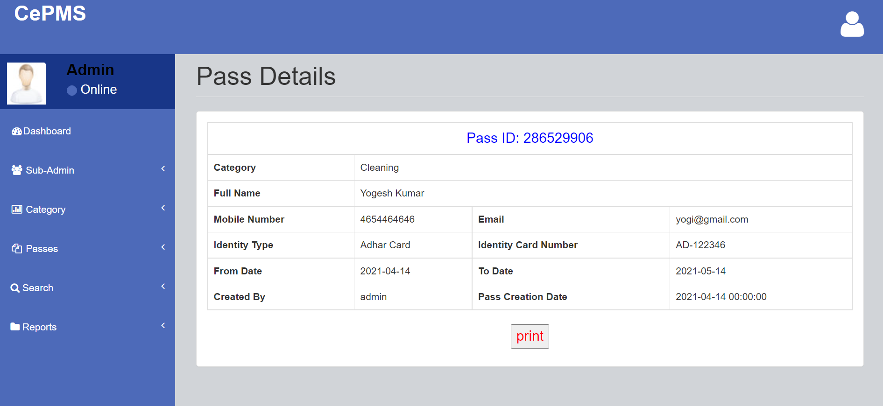

Screenshot 7.11 Pass Details

Edit Pass
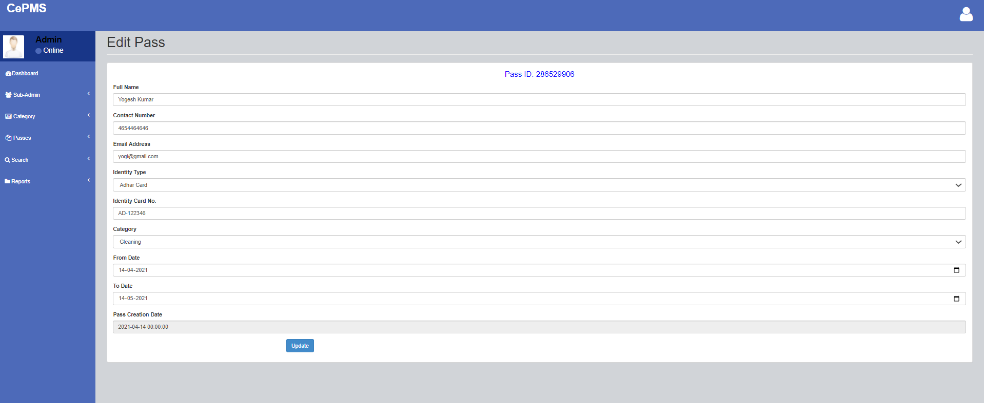

Screenshot 7.12 Edit Pass

Search Pass
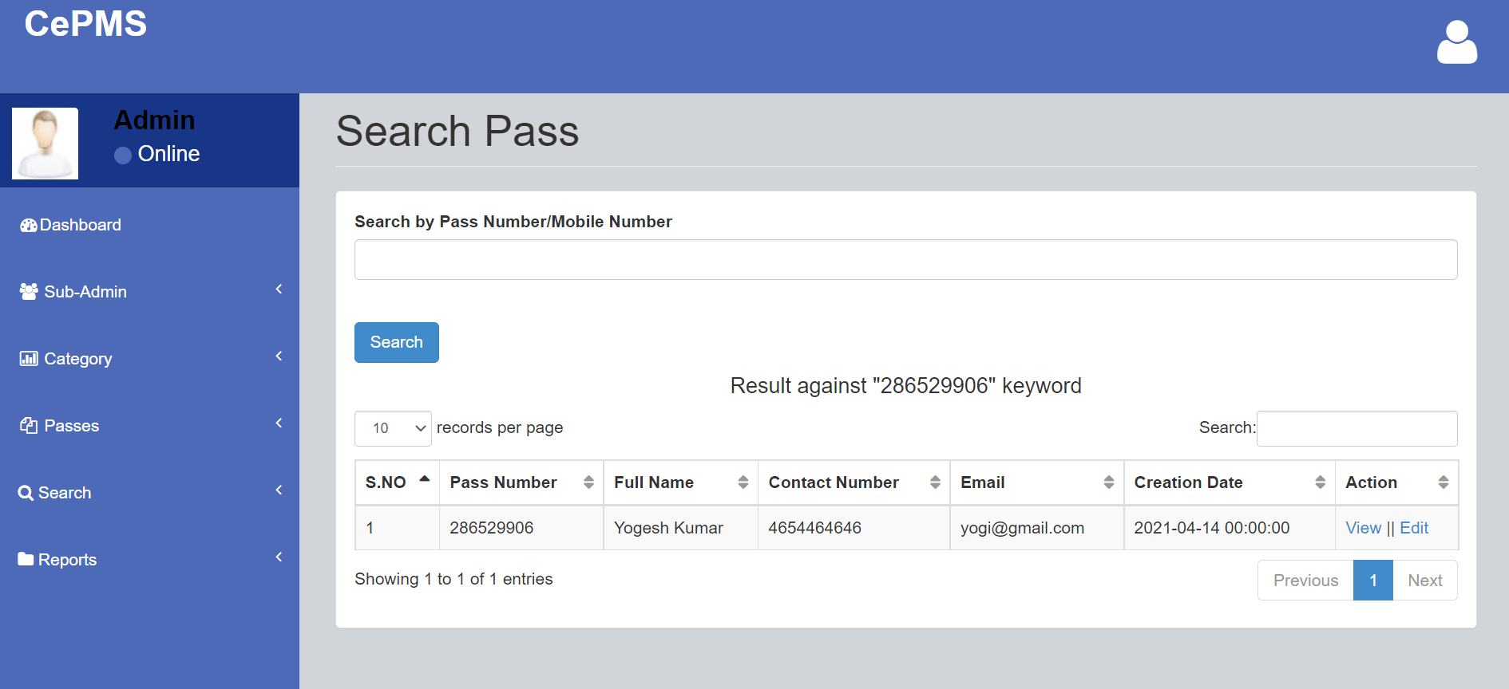
Screenshot 7.13 Search Pass

Between Dates Reports
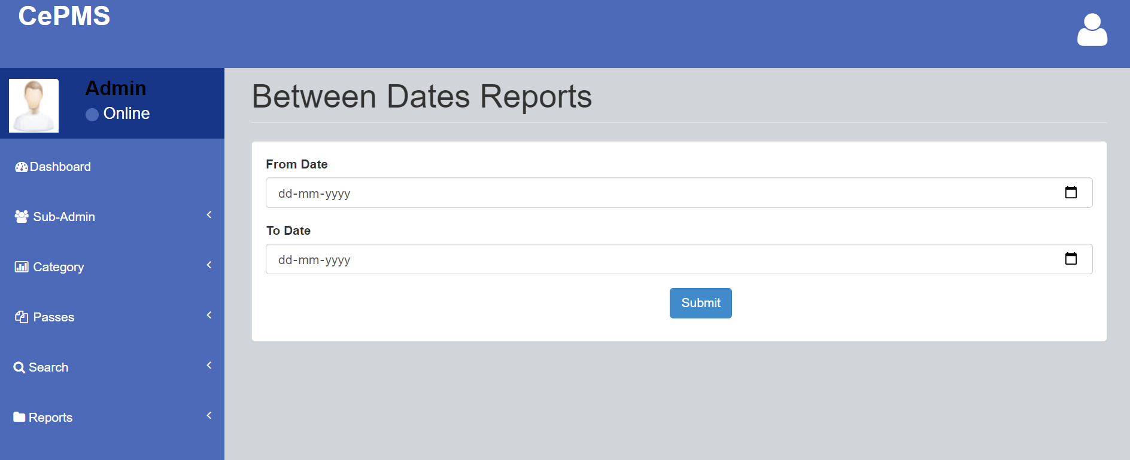

Screenshot 7.14 Between Dates Reports

View Between Dates Reports
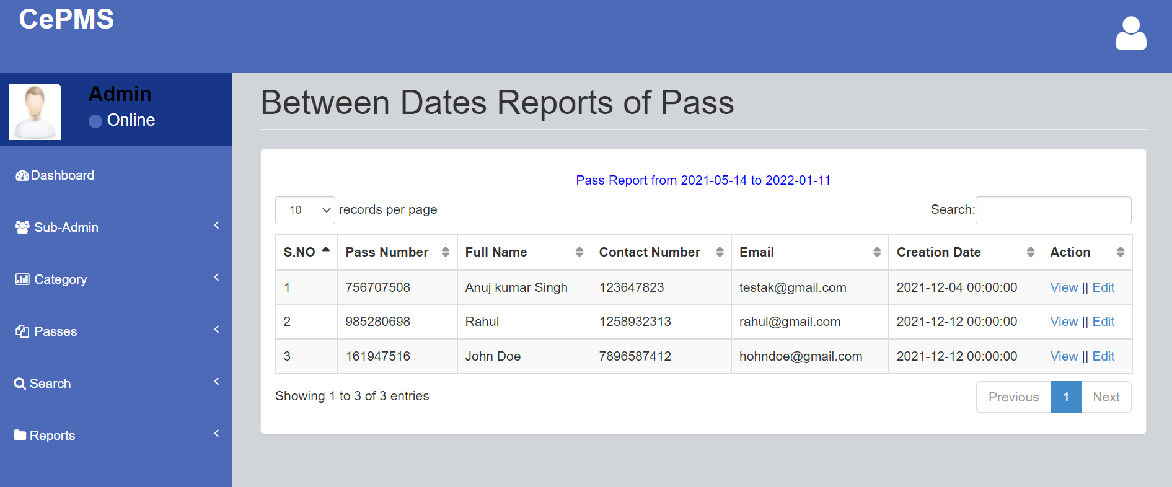

Screenshot 7.15 View Between Dates Report

Forgot Password
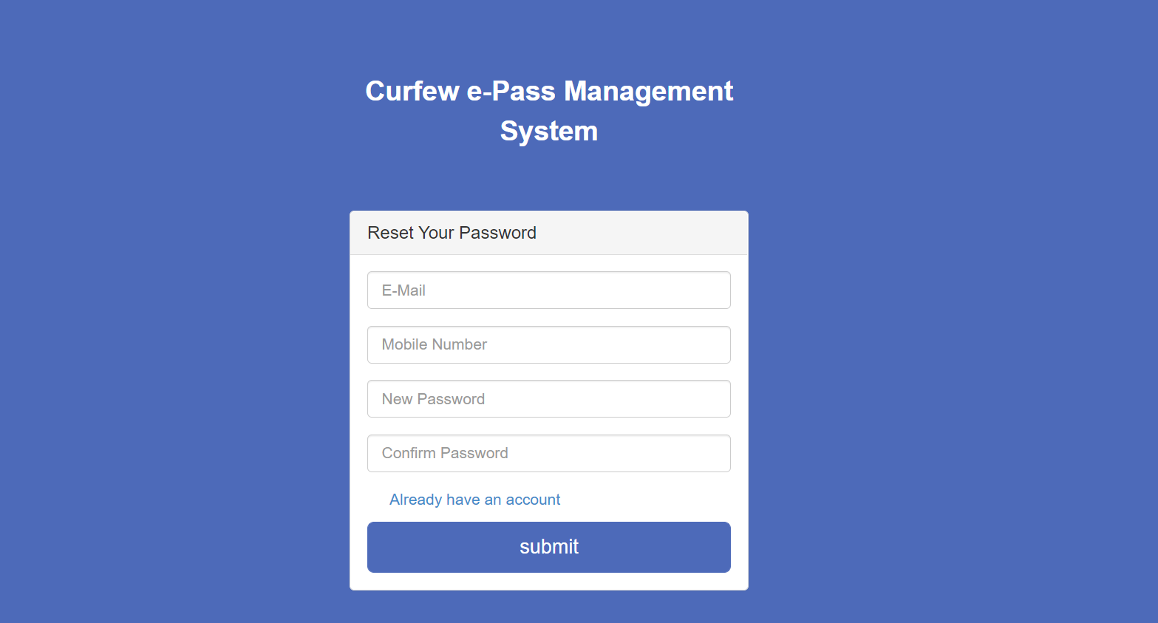

Screenshot 7.16 Forget Password

CONCLUSION

CPMS has many powerful features and is certainly more than a "simple" diagramming tool. With its support of MDA (Model Driven Architecture), it is more aimed at people using UML in an intensive way and with some code generations objectives than for simply drawing diagrams to document requirements. However, using CPMS just as a diagramming tool work fine, especially on Windows as the tool is built with Delphi and might execute faster than the Java-based tools. Modern world is computer world where the things have to be done promptly that requires optimal resources and optimal methods. Due to this inevitable requirement, computerisation of each and every sector in the main stream is must, so that it can be held itself in the race. Few eye catching features of our project are its simplicity, accuracy, and its user friendly interface. Our software incorporates all the features and facilities provided by the Visual Studio software. This project has been developed to manage the entire working of the Curfew Pass administrative. Our software simplifies and replaces all the manual effort and the paper works done by the administrative to a completely electronically environment. Hence both the user and the administrative are at their ease. The user is serviced at his footsteps wherein he just types in the request and he is just a click away. We would like to convey our sincere gratitude and thanks to all, who stood as our backbone, in designing, formatting and helping us in executing this project successfully.

REFERENCE

For PHP
- https://www.w3schools.com/php/default.asp
- https://www.sitepoint.com/php/
- https://www.php.net/

For MySQL
- https://www.mysql.com/
- http://www.mysqltutorial.org

For XAMPP
- https://www.apachefriends.org/download.html

